Econ Review: Revisiting the Sixth District Coincident Indicator

When trying to assess the overall state of an economy one can usually find a plethora of different and sometimes even contradictory indicators. The unemployment rate, industrial production, inflation or perhaps a broader measure like the gross domestic product (GDP) could all be used to sketch a picture of how business conditions are evolving in general.

However, it is not clear which one is the right measure to focus on since each of these statistics has some, yet not all the relevant information we are looking for. Additionally, more often than not, these figures can give conflicting signals about where we are in the business cycle, creating confusion and leading to misguiding interpretations and sub-optimal recommendations.

One solution to this problem is to combine several measures into a composite index of current economic activity. This was the main objective of the Sixth District dynamic common factor model (D6) developed in our original study (Silos and Vilán 2007). That model sought to combine disaggregated information for each state within the District and provide an estimate of an unobserved common component which would account for the major shifts in economic activity in it. In that study we also showed that such an indicator would yield better results than the traditional practice of averaging state-level factors as the D6 Factor was able to filter out idiosyncratic shocks that would disproportionately impact one of the states in the sample.

In this article we continue to build on our original model and seek to improve it in several ways. While the original D6 based its estimation on 25 distinct data series, the new version does so on 48. Moreover, the sample period under which the estimation is performed was increased by a decade. Both changes provide the model with substantially more information and, at the same time, reduces the incidence that certain key series (like employment) had in the original common factor movement. Furthermore, having a longer data set allows for historical comparisons as the model is now being estimated across several business cycles. Last, the new model has the capacity to handle both data at the monthly as well as quarterly frequency, a desired feature which greatly increases the options available to the researcher.

Our aim is that through a thorough understanding of the dynamics behind this common factor, academic, policymakers, and businesspeople will be able to make better diagnosis of the condition of the region’s economy. Furthermore, when compared to those of the nation or other Federal Reserve districts, we believe our model could assist in identifying crucial differences and similarities used to develop more accurate diagnostics and in turn support monetary policy formulation.

The Methodology:

In the late 1980s James Stock and Mark Watson developed an econometric model that estimated changes in the underlying state of an economy. Naturally, these changes are never observed directly, but rather reflected in a wide array of indicators such as industrial production, the unemployment rate, the housing market, etc. Using the estimated changes in the underlying conditions of the economy, Stock and Watson constructed a coincident indicator for the national US economy.

The model presented in this study remains heavily based on the coincident indicator approach pioneered by Stock and Watson (1989). However, given the size of our data set, we continue to follow closely the methodology employed by Otrok, Silos, and Whitman (2003) in which the estimation is done sequentially rather than in a one “block” approach. Yet perhaps the biggest methodological addition has been to allow for the inclusion of quarterly data into the coincident index.

When working with state level data, a researcher faces constraints that do not generally arise at a national level simply because fewer monthly data series are available at the sub-national level. As such, as we aimed to improve our estimation by expanding the number of series employed we sought out ways to articulate state-level quarterly data into our model. We achieved this by following Chow and Lin’s (1971) proposed method for interpolating lower frequency into high frequency data series (refer to the appendix for technical details).

The Setup:

We continue to model the economic activity in the Sixth District as being driven by an unobserved common factor. Economic activity in this case will be measured by a large set of monthly economic statistics. Disaggregated information for each state is thus incorporated into a model from which the common component is estimated. In such a view, the model as well as the methodology greatly resembles the one described in Silos and Vilán (2007):

There are observed variables denoted 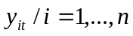 that reflect economic activity (employment, income, housing, etc) in period 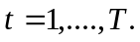 Note that each refers to a specific data series; for example 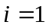could be housing starts in the state of Georgia while 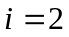could be so in Alabama. It should also be noted in the case of a quarterly data series, such as personal income, one should perform the Chow-Lin decomposition prior to performing the estimation. In other words, all data series included in 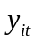 should be monthly.

A single common factor 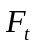 is assumed to account for all comovement among the variables. Furthermore, the factor is assumed to be latent (unobserved) and related in a linear fashion to the proposed observables:

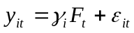

where the error terms follow an autoregressive process of the type:

and the equation describing the common factor dynamics has an autoregressive structure as well:

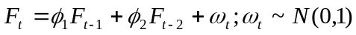

Data Description:

As previously mentioned, a total of 48 series will be used to perform the estimation. These time series data could be classified into four groups: employment, housing, industrial activity and income statistics. Data are monthly, starting in January 1980 to December 2008. Contrary to the original version of the model, we have included no series for which data is not available for every state in the district. Since most of the series used in this application are not seasonally adjusted we run the model in year-over-year growth rates to avoid problems with seasonality. A brief description of each series is offered below:

Employment. The employment statistics used include total nonfarm payroll employment and the unemployment rate for all six Southeastern states. The data on nonfarm employment is monthly, not seasonally adjusted and provided by the Bureau of Labor Statistics (BLS). The series includes payroll data from construction, trade, government, transportation and utilities amongst other important sectors of the economy. The unemployment data per state is also not seasonally adjusted and provided by the BLS. This statistics track the proportion of the labor force 16 years and over, who were available for work, made specific efforts to find employment yet were unsuccessful at this search.

Housing. Given the relative importance of the housing sector (approximately one quarter of all investment spending and about five percent overall GDP), se sought to increase the representation it had in our model by including additional data series. Hence, the housing statistics employed include the number of housing starts as well as the number of housing permits awarded per month per state. The data on housing permits is provided by the Census Bureau and refers to the new privately owned housing units authorized by building permits in each state. The data on housing starts track the number of housing units that are under construction by purpose and design. Both series are not seasonally adjusted.

Income. Variations in the agents’ disposable income will undoubtedly be governed by business cycle dynamics. States’ sales tax receipts and personal income are the series used to account for variations in disposable income throughout the business cycle. State tax receipts are reported monthly by each state’s Department of Revenue or Tax Commission and are an important indicator of each state’s fiscal strength. Current month rather than year-to-date receipts are employed. On the other hand, personal income is a measure of individuals’ purchasing power. The statistic is reported quarterly and is published by the Bureau of Economic Analysis (BEA). Note that following Crone (2000), we exclude transfer payments from our measure of personal income since transfer payments are typically insulated from business cycle dynamics.

Industrial Activity. Given the lack of state-level industrial production indexes, we employ two statistics to approximate the degree of monthly industrial activity: the average number of hours worked in manufacturing and the industrial electrical consumption per state. Average hours worked in manufacturing are reported monthly by the BLS and are not seasonally adjusted. This statistic tracks the average of weekly hours worked by production workers in manufacturing industries. If demand for production holds up, businesses will be forced to hire additional workers, signaling a strengthening economy. On the flip side, if demand for production slows, employers will ask workers to work fewer hours before laying them off presumably signaling a weakening economy. Industrial electrical consumption by state is published by the Department of Energy (DOE), measured in Mega Watts per hours (MWh) and is not seasonally adjusted. Data available on the DOE website went back until January 1990, so the first ten years of our data set needed to be backcasted based on the 18 years of available data.

Estimation Results:

To summarize the results of our model we resolve to two things: First we describe the evolution of the unobserved component for the Sixth District and compare the predicted business cycles to those of the national economy as defined by the National Bureau of Economic Research (NBER). Finally, we study the effects that changes to the model have had to the way specific factors are weighted from one version to the next.

Figure 1 shows the median of the estimated common component along with its 10th and 90th percentiles. Given that the common factor is, in essence, a random variable we should keep in mind that it will have a distribution at each point in time. The percentiles plotted along the median are an indication of the uncertainty surrounding such a distribution.

[Figure1]

Figure 2 again plots the median of the common factor together with bars that represent the official beginning and end of national recessions as established by the business cycle dating committee of the NBER. We can appreciate that the D6 is always in negative territory whenever there is a
The index show economic downturns in each of the States corresponding to the National Recessions

[Figure 2]

As for the

Conclusion:

The economic activity indexes are primarily a measure of state business cycles.

A primer on Chow-Lin Interpolation:

A recurrent problem in empirical macroeconomics is the desire to employ high frequency data when the researcher can only really depend on lower frequency one. For example, one would like to have an estimate of monthly GDP, yet GDP is only released once a quarter by the BEA.

One way of solving this issue is to take advantage of the relationship between those series released at lower frequencies and those released at higher ones. For example, one could use monthly data on consumption, industrial production and employment which are greatly correlated with GDP to infer what monthly GDP might have been.

A classic paper by Chow and Lin (1971) proposed a method for doing just this. In fact, under their assumptions, their method produces the best linear, unbiased estimate of the high-frequency data. Without loss of generality we will refer here to an interpolation between a quarterly time series to the monthly frequency. But the same approach could be used to interpolate an annual time series to the quarterly frequency and so on.

Assume that 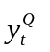is the quarterly times series that the researcher observes but would like to use at a higher (in this case monthly) frequency. We assume a relationship of the following type: 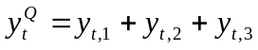, where 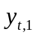denotes the series in the first month of the quarter and so on. In the month i of quarter t the researcher is, nonetheless, able to observe other variables which are assumed to be related to in the following manner:

and that
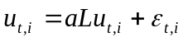

Where L denotes the monthly lag operator, which could be in the previous quarter and 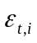is iid with mean zero and variance . Accordingly, the 3Tx3T variance-covariance matrix of monthly errors is:

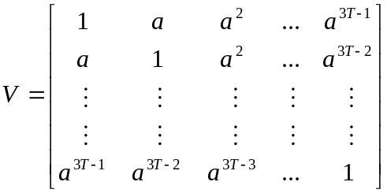

Let 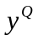and 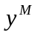denote the vectors of quarterly and monthly series of lengths T and 3T respectively. Then one could write 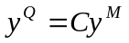where:

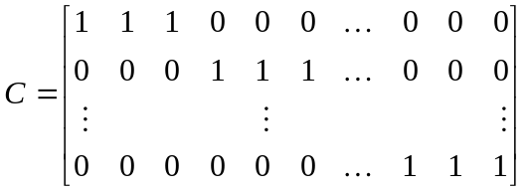

In that same fashion, we could form quarterly estimates with those series that are available to the researcher on a monthly frequency. As such, let 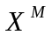be the 3TxP matrix of the monthly variables and define 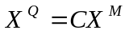. With this expression, we can write our original equation in the form 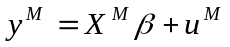and the premultiply this by C to yield:

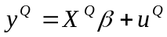

where 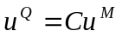. In this regression the variance-covariance matrix of errors is CVC’ and multiplying this out, the first autocorrelation of the errors can be calculated as:

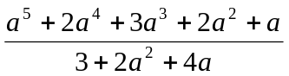

With all these building blocks, one could summarize the Chow-Lin interpolation procedure as follows:

First, construct the observed quarter series, from the observed monthly ones:

Second, obtain the OLS estimates from quarterly observed data:

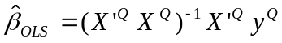

Next, calculate the first order autocorrelation of the residuals from this OLS regression and find the value of “a” that sets the value of CVC’ to this autocorrelation. With this value of a, obtain an estimate of V named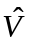. Given this estimate, obtain a FGLS estimate by:

Finally, obtain the corresponding residuals: 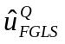and use this to obtain the monthly estimate. Chow and Lin show that this will be the best linear, unbiased estimator:

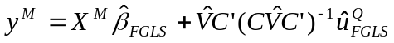

These notes draw heavily from Jonathan Wright’s (2009) summary on the Chow-Lin interpolation.

